Multi-Model AI Image Generation Pipeline
An n8n-Orchestrated, Notion-Logged, Async Agentic Workflow

1. Overview
This system is a self-serve image generation pipeline that lets a user pick from four different AI image models, submit a prompt (with optional reference images) through a web UI, and get back finished, upscaled, cloud-hosted images — with every request automatically logged, tracked, and error-monitored in Notion.
At a glance, the stack is:
Layer | Technology
Front end / launcher | Static HTML + JS (nano-banana-launcher.html)
Orchestration engine | n8n (2 workflows)
Model providers | fal.ai (Nano Banana Pro, FLUX.1 Kontext [pro], GPT Image 2, Topaz Upscaler)
Storage | Google Drive
System of record / logging | Notion database
Error handling | Dedicated n8n error-trigger workflow

The design goal was to turn four very different, unrelated model APIs (different auth patterns, different sync/async behavior, different response shapes, different pricing) into one uniform request/response contract that a simple front end and a simple polling loop can talk to — without the user needing to know which model is synchronous and which is a job queue.

2. Architecture at a Glance
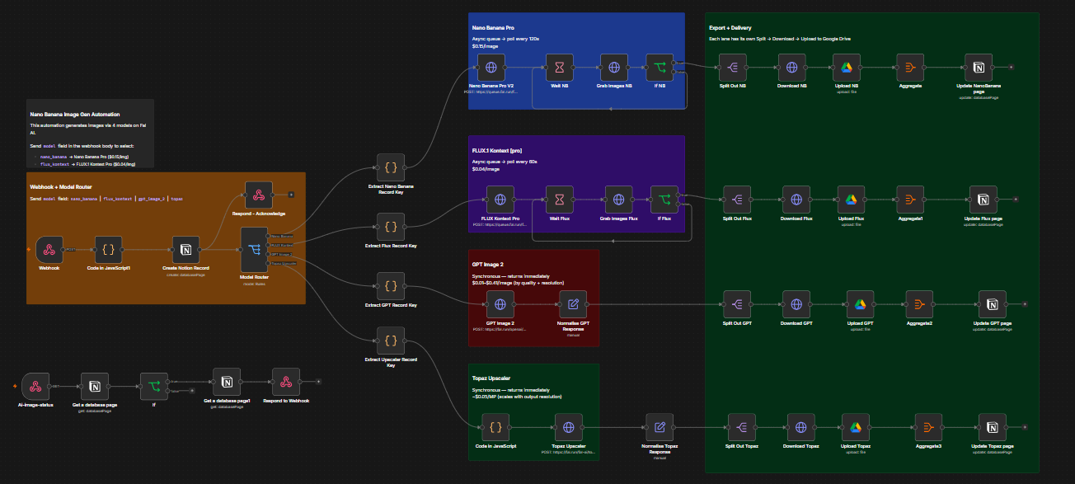
n8n canvas — full pipeline (intake → model routing → export & delivery)
This is a classic fire-and-acknowledge, poll-for-completion pattern — necessary because two of the four models (Nano Banana Pro, FLUX Kontext Pro) are async job-queue APIs that can take 1–3+ minutes, well beyond any sane HTTP timeout, while the other two (GPT Image 2, Topaz) return synchronously in seconds. Rather than exposing that asymmetry to the client, the workflow normalizes everything behind a single "check back later" contract.

3. The Front End (nano-banana-launcher.html)
A single self-contained HTML/JS launcher (no build step, no framework) serves as the operator console:
- Model selection — a switch/toggle for the four supported model values: nano_banana, flux_kontext, gpt_image_2, topaz.
- Prompt + reference image upload — the standard fields plus model-specific options (aspect ratio, resolution, output format, quality, upscale factor, face enhancement, etc.).
- Two configurable webhook URLs — one for kicking off generation, one for status polling — so the same static HTML file can point at any n8n instance without code changes.
- Async result polling module — this is the most important piece of client logic. Rather than a naive setInterval, it uses a recursive setTimeout so the first check and subsequent checks can have different delays:
POLL_INITIAL_DELAY_MS = 60000 // wait 1 min before first check
POLL_INTERVAL_MS = 30000 // then check every 30s
POLL_MAX_ATTEMPTS = 11 // gives up after ~6 minutes total

This matters because polling every 30s from second zero would just waste calls hammering a job that provably takes at least a minute (Nano Banana Pro's own internal wait is 120s). Front-loading the wait reduces total request volume while still surfacing results as soon as realistically possible.
- Dual response detection — the client inspects the initial webhook response and decides whether it's a synchronous result (image URL already present) or an async acknowledgment ({status:"processing", recordId}), and only starts the polling loop in the latter case.
- Status UI — pills/badges (idle, uploading, done, error) driven off the polled Notion status, plus a friendly timeout message that points the user at the recordId for manual investigation in the n8n execution log if the pipeline gives up after ~6 minutes.

4. Main Workflow — Request Intake & Routing
Trigger: Webhook node at path Ai-image-generation, POST, responseMode: responseNode (so the workflow controls exactly when and what it replies with, rather than n8n auto-responding immediately).
Step 1 — Normalize the request (`Code in JavaScript1`). Every incoming payload, regardless of model, is passed through a small transform that builds a notion_payload object with a consistent shape (Name, Model, Prompt, OutputFormat, NumImages, ImageURLs, WebhookURL, Status: "Processing"), while still passing the raw body through untouched for the model-specific branches downstream.
Step 2 — Create the Notion tracking row (`Create Notion Record`). Before any model API is even called, a new page is created in the AI Image Generation Logs Notion database with Status = Processing and Launched At = now(). This means the record exists — and is visible/trackable — the instant a request comes in, not just once it finishes. This is what makes the whole "poll by recordId" pattern possible on the front end.
Step 3 — Acknowledge immediately (`Respond - Acknowledge`). The webhook responds right away with:
{ "status": "processing", "recordId": "<notion page id>", "notionUrl": "<notion page url>" }

This keeps the HTTP request short-lived (avoiding gateway/proxy timeouts on long model jobs) and hands the client exactly what it needs to poll for the result.
Step 4 — Route by model (`Model Router` — a Switch node). A single body.model string field fans out into four independent branches:
model value | Routed branch
nano_banana | Nano Banana Pro
flux_kontext | FLUX.1 Kontext [pro]
gpt_image_2 | GPT Image 2
contains "topaz" | Topaz Upscaler

Each branch is visually color-coded and boxed with a sticky note in the canvas (see the screenshot) documenting its cost and sync/async behavior — a nice bit of self-documenting workflow design.

5. The Four Model Branches
All four branches call fal.ai endpoints via generic HTTP Header Auth credentials, but each has a distinct interaction pattern:

5.1 Nano Banana Pro — async, $0.15/image
- POST https://queue.fal.run/fal-ai/nano-banana-pro/edit — a queue-based endpoint. The request body is built entirely from the incoming webhook fields with sane defaults and hard caps (e.g. num_images clamped to max 4, resolution defaults to 1K, safety_tolerance defaults to 4), so a malformed or partial client payload can't break the call.
- Wait NB — the workflow pauses 120 seconds before checking back (matches the sticky note: "poll every 120s").
- Grab Images NB — GETs the job's response_url returned by the queue submission.
- If NB — checks images[0].url exists; if not, the branch effectively has nothing to hand downstream (this is the seam where the separate error-trigger workflow catches genuinely failed/stuck jobs).

5.2 FLUX.1 Kontext [pro] — async, $0.04/image
- POST https://queue.fal.run/fal-ai/flux-pro/kontext — same async queue pattern, but with FLUX-specific parameters (guidance_scale, enhance_prompt, single image_url rather than an array).
- Wait Flux — 60 second poll delay (cheaper/faster model, shorter queue wait).
- Grab Images Flux → If Flux — identical shape check to the NB branch.

5.3 GPT Image 2 — synchronous, $0.01–$0.41/image
- POST https://fal.run/openai/gpt-image-2/edit — note the non-queue fal.run host (vs queue.fal.run) — this call blocks and returns the finished image(s) directly, no polling needed.
- Normalise GPT Response — a Set node that simply remaps the response into the same { images: [...] } shape the other branches use, so everything downstream (Split Out → Download → Upload → Notion update) is model-agnostic.

5.4 Topaz Upscaler — synchronous, ~$0.05/megapixel
- Code in JavaScript — a fairly sophisticated payload builder that only includes optional fields (face-enhancement strength/creativity, sharpening controls, crop-to-fill) if they were actually supplied, rather than sending nulls/defaults for every possible Topaz parameter. Model list includes Standard V2, High Fidelity V2, Low Resolution V2, CGI, Text Refine, Redefine, etc.
- POST https://fal.run/fal-ai/topaz/upscale/image — also synchronous.
- Normalise Topaz Response — remaps Topaz's single-object image: {url, content_type, file_name} reply into the same images: [...] array shape used everywhere else.

Design note: this normalization step (images: [...]) is the key abstraction that lets one shared export pipeline (below) serve all four branches without four separate copies of download/upload/log logic.

6. Export & Delivery Pipeline (shared shape, per-branch instance)
Once a branch produces its normalized images[] array, each lane runs the identical five-step delivery sequence:
- Split Out — fan the images[] array into individual items (n columns of splitOut, one per branch: NB, Flux, GPT, Topaz).
- Download — HTTP GET each image URL as binary data.
- Upload to Google Drive — pushes the binary into a shared Drive folder (Outfit_folder_n8n), file named from the binary's original filename.
- Aggregate — collects the resulting Drive webViewLinks for all images belonging to that request back into a single list (four parallel Aggregate nodes, one per branch).
- Update Notion page — the original "Processing" row (matched by the record ID captured right after Create Notion Record) is updated with Status → Done, Finished At → now(), Output Image URLs → <newline-joined Drive links>, and model-specific extras where relevant (e.g. NB writes back Aspect Ratio / Resolution).

Each branch has its own small Extract <Model> Record Key code node earlier in the flow — this exists purely to carry the Notion page.id created at request time through the (potentially minutes-long) async wait, so the final update targets the same row rather than creating a duplicate.

7. Status Polling Endpoint (second webhook)
A second, independent webhook — Ai-image-status — exists purely so the front end has something fast and cheap to poll, instead of re-triggering the whole generation logic:
- Get a database page — fetches the Notion row by query.recordId (passed as a query-string parameter from the client, e.g. ?recordId=...).
- If — checks whether property_status is Done or Error (an OR condition) — i.e., "is this row in a terminal state yet?"
- Get a database page1 — re-fetches the page (ensures the freshest state is used for the response, guarding against any race between the check and the reply).
- Respond to Webhook — returns a minimal JSON payload, with CORS headers open (Access-Control-Allow-Origin: *) so the static HTML file can call it from anywhere, including file:// or any static host:
{ "URL": "<property_output_image_ur_ls>", "Status": "<property_status>" }

This is a clean separation of concerns: the generation workflow never has to "wait around" or keep a connection open for the full duration of a model job; the status workflow is a cheap, stateless read against Notion that the client can call as many times as it needs.

8. Error Handling Workflow
A second, fully independent n8n workflow (AI_image_generation_Error_Logs.json) exists specifically to catch failures that happen inside the main workflow's execution:
- `Error Trigger` — n8n's built-in trigger that fires automatically whenever another workflow throws an unhandled error.
- `Get many database pages` — queries the Notion database for any row where Status = Processing and Finished At is empty — i.e., requests that were started but never got a terminal update, because the run that would have updated them just crashed.
- `Update a database page` — writes back to that stuck row: Status → Error, Finished At → now(), and Error Detail — a formatted string combining the error message, the first 1500 characters of the stack trace, and the name of the node that failed (execution.lastNodeExecuted), all pulled straight from the trigger's execution context.

This is a good pattern for two reasons:
- It decouples failure handling from the happy path — none of the four model branches need their own try/catch logic; any crash anywhere in the main flow (a malformed API response, an auth failure, a Google Drive quota error, etc.) is caught centrally.
- It closes the loop for the polling client — without this, a crashed run would leave the Notion row (and therefore the polling front end) stuck at Processing forever, since nothing would ever move it to Done. The If node in the status webhook explicitly checks for Error as a second terminal state precisely so the client's poll loop stops and surfaces a real failure message instead of timing out silently.

9. Notion as the System of Record
The Notion database (AI Image Generation Logs) is deliberately the single source of truth that both n8n workflows and the front end all read/write against — it functions as a lightweight job queue's state table, without needing a separate database. Its schema (from the export) covers three concerns at once:
Concern | Fields
Request | Model, Prompt, Aspect Ratio, Image Size, Resolution, Seed, Num Images, Image Count, Image URLs, Output Format, GPT Quality, Topaz Model, Upscale Factor, Face Enhancement
Lifecycle | Status, Launched At, Finished At, Processing Time
Result / failure | Output Image URLs, Error Detail

This gives a full audit trail per generation — what was asked for, which model handled it, how long it took, and where the finished (or failed) assets ended up — with zero extra infrastructure beyond a Notion database and its existing n8n integration node.

10. Why This Design Works Well
- One contract, four backends. The images[] normalization step means adding a fifth model later is a matter of adding one HTTP call + one Set/normalize node — the entire export → Drive → Notion → status pipeline is untouched.
- Async is hidden from the client. The front end never needs to know that Nano Banana Pro takes ~2+ minutes and GPT Image 2 takes ~2 seconds. It always gets an immediate ack + a recordId, and always polls the same way.
- State lives in one place. Notion is simultaneously the job queue, the audit log, and the API the status webhook reads from — there's no risk of the front end and backend disagreeing about job state.
- Failure can't strand a job silently. The error-trigger workflow guarantees every "Processing" row eventually reaches a terminal state (Done or Error), which is what makes the client's bounded polling loop (11 attempts, ~6 minutes) safe rather than a request that could hang forever.
- Defensive payload building. Every model branch clamps, defaults, or JSON-stringifies user input before sending it upstream (e.g. capping num_images at 4, defaulting safety_tolerance, only including optional Topaz fields if actually supplied) — reducing the chance that a sloppy front-end payload causes a hard failure at the model API rather than a graceful fallback.

